The Dewey 2027ADM
3 beds | 2 baths | 1,260 sq. ft. | 16x88

OPT. WINDOWS THERMAL ZONE 1 ONLY

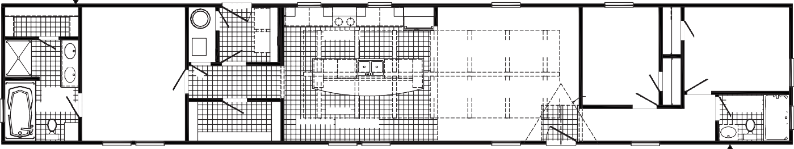
3072 SG PICTURE
FAUCET
3036
3036
3660
3660-E
3680
W/H
REFER
KITCHEN
F
3RD BEDROOM
8'-2" X 10'-6"
OPT. DW
OPT. BEAM
2ND BEDROOM
11'-2" X 9'-0"
PRIMARY BATH
7'-10" X 10'-10"
DORMER
OPT.
2ND BATH
7'-6" X 5'-0"
PRIMARY BEDROOM 11'-0" X 14'-4"
DINING
OPT. TREY CEILING 16'-0" X 14'-4"
LIVING ROOM 15'-5" X 14'-4"
3660-E
3660
3660
3660
3660
3680
3660
OPT.
FAUCET
OPT.
RAG
DRAWER
RAG
3036 SG
36 X 72
48 SHWR
WASH
DRY
OPT. BEAM
OPT. BEAM
OPT. BEAM
OPT. BEAM
OPT. BEAM
OPT. BEAM
OPT. BEAM
OPT. BEAM
OPT. BEAM
OPT. BEAM
OPT. BEAM
OPT. BEAM
OPT. BEAM
OPT. BEAM
3012 TR
OPT. WZ 1
& 2 ONLY
3660-E
60"
RAG 24X4
3072 SG PICTURE
3072 SG PICTURE
3072 SG PICTURE

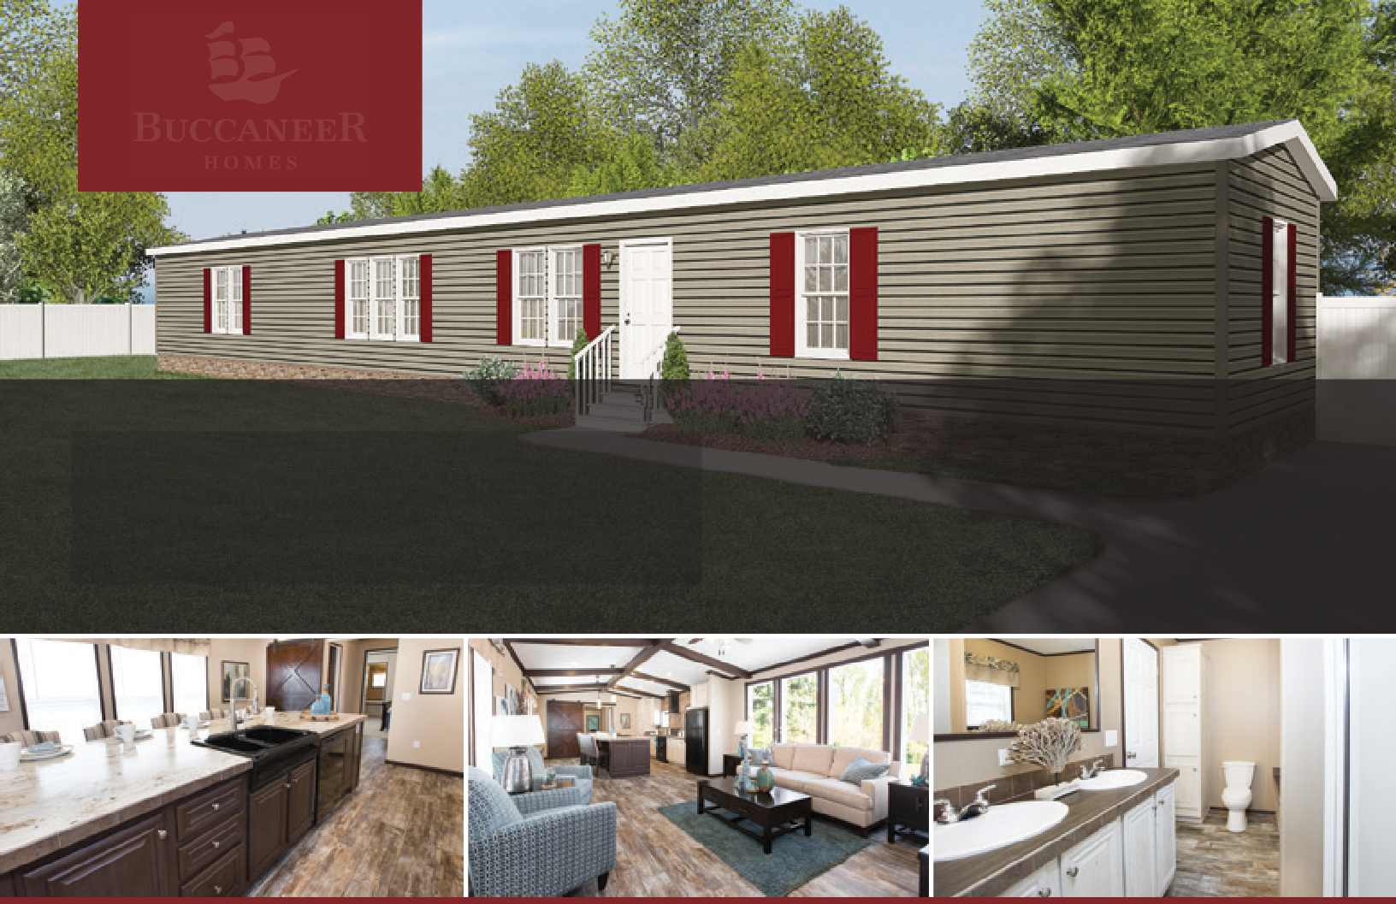
LINEN

The home series, floor plans, photos, renderings, specifications, features, pricing, materials and availability shown will vary by retailer and state, and are subject to change without notice.

