The Bobby Jo
3 beds | 2 baths | 1,260 sq. ft. | 16x84

OPT.
3012 TR
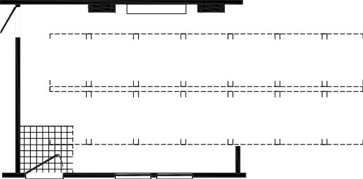
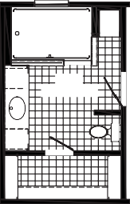
ENT. CENTER
OPT. BEAM
OPT. TREY CEILING OPT. LIVING ROOM
18'-4" X 14'-4"
3680
OPT. BEAM
OPT. BEAM
OPT. BEAM
OPT. BEAM
OPT. BEAM
OPT. BEAM
OPT. BEAM
OPT. BEAM
OPT. BEAM
OPT. BEAM
OPT. BEAM
OPT. BEAM
RAG 24X4
LINEN
48 X 72 SHILOH

SAFETY GLS.
DRWR
8'-8" X 10'-9"
BATH

OPT. SHOWER
3660
3660

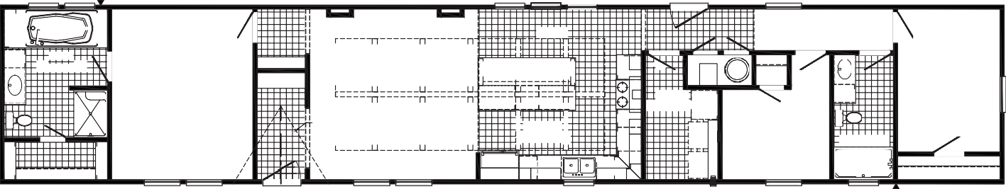
3036 SG 3036 SGFAUCET
OPT. CUBBIES

36 X 72

ENT. CENTER

3072 SG PICTURE
RAG 24X4

3072 SG 3072 SG PICTURE PICTURE

DINING
OPT. BEAM
OPT. BEAM
OPT. BEAM
OPT. BEAM
OPT. BEAM

3680

OPT. 3660

DRWR

BATH
RAG
RAG
8'-8" X 10'-9"

PRIMARY BEDROOM 11'-10" X 14'-4"
DRY

FLOATING SHELVES

BENCH/COAT RACK

3680

OPT. DORMER

OPT. TREY CEILING
OPT. BEAM
OPT. BEAM

LIVING ROOM
14'-0" X 14'-4"

OPT. BEAM
48 SHWR
OPT. BEAM

REFER

DRWR

KITCHEN 13'-9" X 14'-4"
OPT. BEAM
OPT. BEAM

DW

DRWR

F

UTILITY 6'-1" X 10'-6"
RAG 24X4
WASH FREEZER
SPACE

W/H

3RD BEDROOM
9'-0" X 10'-6"

DRWR

5'-0" X 10'-7"
2ND BATH
60"

2ND BEDROOM
8'-7" X 11'-6"
3660-E

3660-E 3660
3660
3660

3036 3660-E
3012 TR FAUCET

OPT.

OPT.

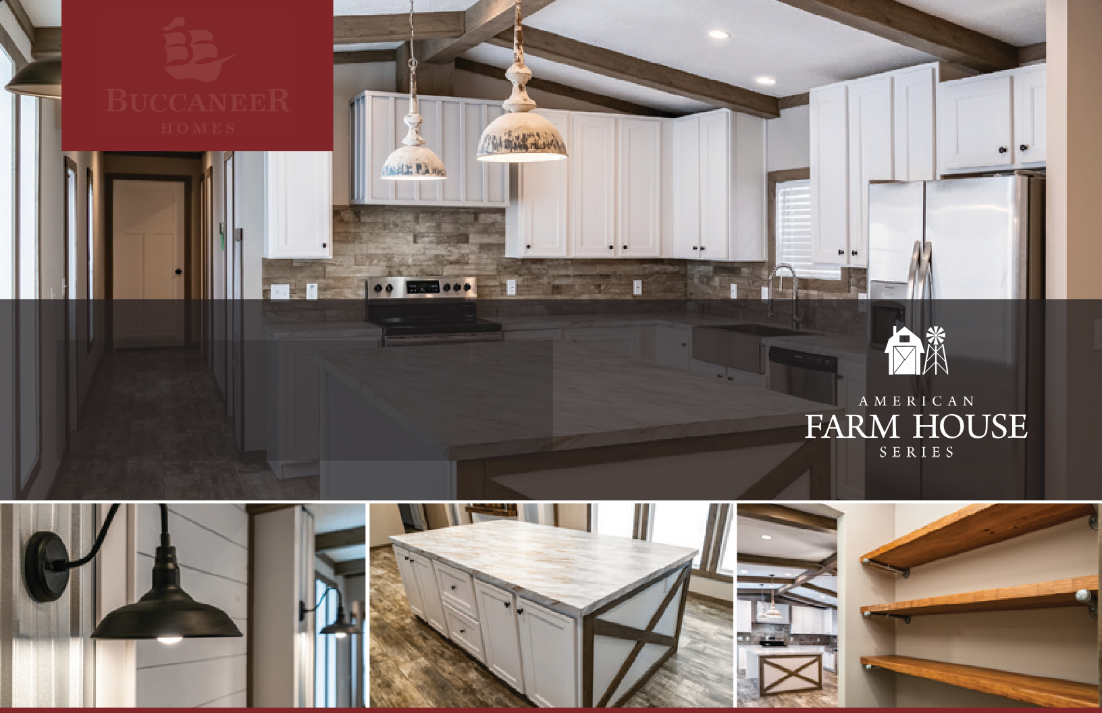

The home series, floor plans, photos, renderings, specifications, features, pricing, materials and availability shown will vary by retailer and state, and are subject to change without notice.

