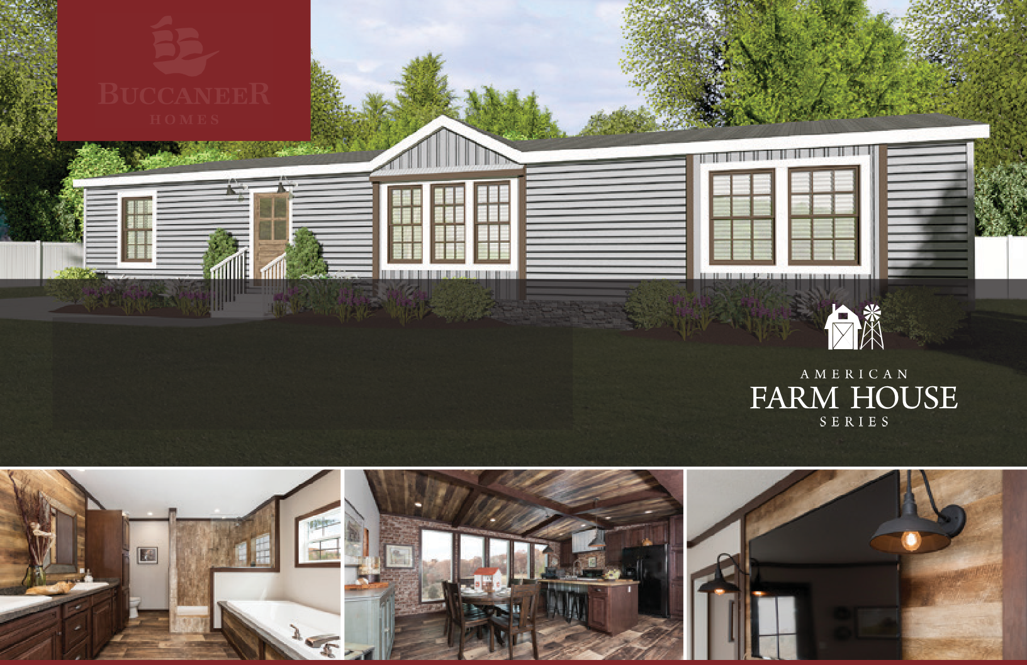

The Avalyn 5039AFH
3 beds | 2 baths | 1,600 sq. ft. | 28x64(60)

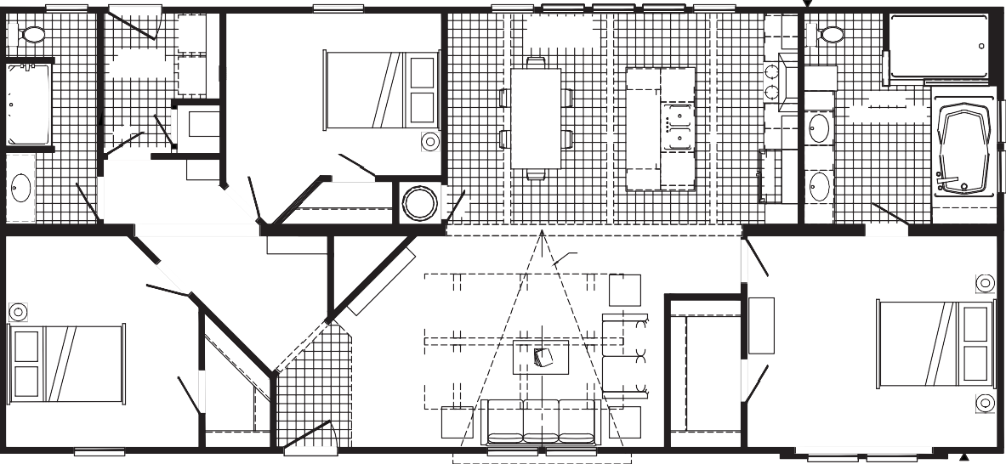
OPT
3036
3660-E
3072 SG 3072 SG 3072 SG 3072 SG PICTURE PICTURE PICTURE PICTURE
3072 SG PICTURE
FAUCET
3680
3RD BEDROOM
12'-11" X 12'-8"
KIT/DINING 21'-0" X 12'-8"
48 X 72 SHILOH
2ND BATH
5'-6" X 12'-8"
UTILITY 7'-0" X 8'-5"
LINEN
SAFETY GLS.
F
BATH
11'-7" X 12'-8"
DRWR
LINEN
W/H
PANTRY
OPT. CUBBIES
BENCH/COAT RACK
LIVING ROOM 23'-4" X 12'-8"
OPT. TREY CEILING
10' DORMER
OPT. BEAM
2ND BEDROOM
11'-7" X 12'-8"
PRIMARY BEDROOM 15'-0" X 12'-8"
3660-E
3680
3660
3660
3660-E
3660 FAUCET
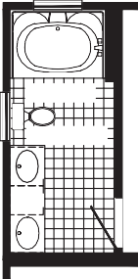
3012 TR
60" VANDERBILT

2ND BATH

5'-6" X 12'-8"
DRWR
3036
60"
WASH
DRY
OPT. BEAM
OPT. BEAM
DRWR
OPT. BEAM
DRWR

OPT. 2ND BATH
RAG
RAG 24X4
OPT. BEAM
OPT. BEAM
OPT. BEAM
OPT. BEAM
OPT. BEAM
OPT. BEAM
DW
REFER
42 X 72
3036 SG 3036 SG
RAG
ENT. CENTER
RAG 20X36

OPT.

The home series, floor plans, photos, renderings, specifications, features, pricing, materials and availability shown will vary by retailer and state, and are subject to change without notice.

