The Tyra B5049ADM
1,813 Sq Ft | 4 Beds | 2 Baths | 28x72

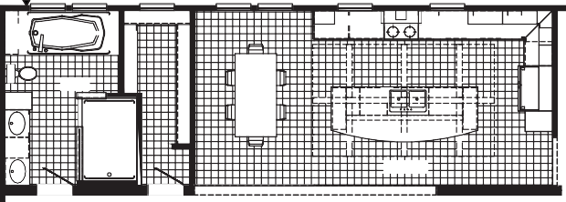
FAUCET
3036 SG 3036 SG
3012 TR
3060
3060
3036
3036
DRWR
36 X 72
BATH
LINEN
OPT. BEAM
PANTRY
DRWR
48 X 72 SHILOH
DINING
OPT. TREY CEILING KITCHEN
OPT. HEADER W/BEAMS
OPT. CUBBIES

OPT.

3060-E

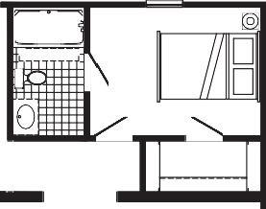
OPT. BEAM OPT. BEAM
OPT. DW
OPT. BEAM OPT. BEAM
OPT. BEAM OPT. BEAM
REFER
5TH BEDROOM
60"
3RD BATH
5'-0" X 8'-10"
11'-10" X 8'-10"
OPT. SHOWER OPT. KITCHEN W/EURO HOOD OPT. 3RD BATH & 5TH BEDROOM

OPT 7280 PATIO DR SLIDE

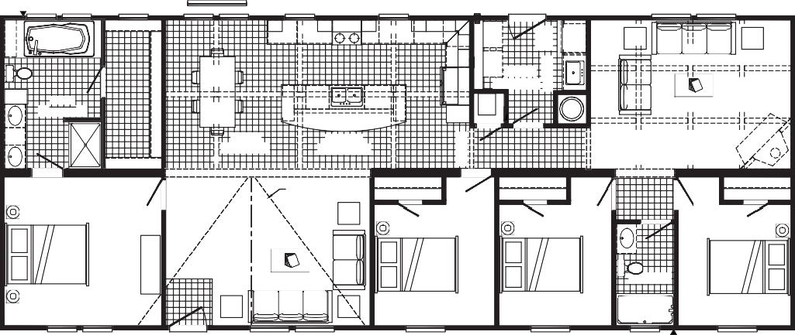
FAUCET

OPT.

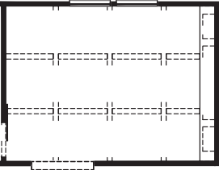
6072(2-3060) W/TRANSOM
FAMILY ROOM WALL W/OPT BARN DOOR
OPT. BEAM
OPT. BEAM
OPT. BEAM
OPT. BEAM
FAMILY ROOM
OPT. HEADER W/BEAMS
OPT. BEAM
OPT. BEAM
OPT. BEAM
OPT. BEAM

3036 SG 3036 SG 3012 TR
OPT. CUBBIES

36 X 72
3060 3060
3036

DRWR
3036

3680
4060 4060
4060 4060

LINEN

DRWR

BATH
8'-4" X 12'-8"
48 SHWR

DINING
OPT. BEAM
8'-8" X 12'-8"

OPT. BEAM

KITCHEN 17'-4" X 12'-8"
OPT. BEAM
OPT. DW

PANTRY
OPT. HEADER W/BEAMS

UTILITY 9'-8" X 8'-10"
OPT. BEAM
OPT. BEAM
OPT. BEAM

F
WASH DRY
OPT. 3' OPT. LAUNDRY CABINETS
RAG

W/H
REFER
SINK

OPT. BEAM
W/O FREEZER
FREEZER SPACE

OPT. BEAM
OPT. HEADER W/BEAMS

OPT. BEAM

OPT. BEAM
OPT. BEAM
OPT. BEAM
OPT. BEAM
OPT. BEAM

FAMILY ROOM 17'-2" X 12'-8"

OPT. BEAM
SHELVES

OPT. BEAM
OPT. ENT. CENTER 113
SHELVES
ETC-103
OPT
OPT. BEAM
OPT BARN DOOR
OPT. BEAM
OPT. BEAM
OPT. BEAM
OPT. FIREPLACE

FP

OPT. HEADER W/BEAMS

OPT.

OPT. HEADER W/BEAMS
OPT. BEAM

20' DORMER
RAG

LIVING ROOM 17'-6" X 12'-8"

PRIMARY BEDROOM 13'-6" X 12'-8"

3680

4TH BEDROOM
10'-4" X 12'-8"

3RD BEDROOM
9'-8" X 12'-8"

2ND BATH
5'-0" X 8'-8"

60"

2ND BEDROOM
9'-8" X 12'-8"

3060-E 3060 4060 4060 4060-E 4060-E
3012 TR FAUCET
4060-E

OPT.
OPT.

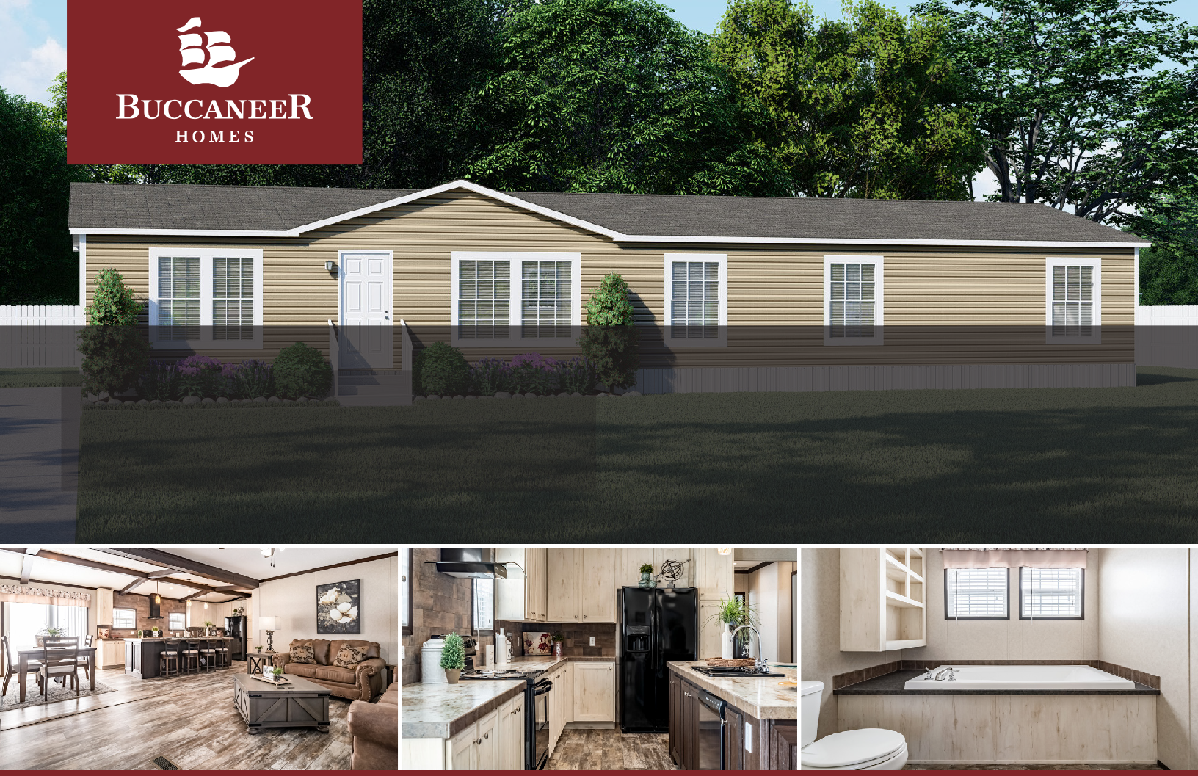

The home series and floor plans indicated will vary by retailer and state. Your local Home Center can quote you on specific prices and terms of purchase for specific homes. Buccaneer Homes invests in continuous product and process improvement. All home series, floor plans, specifications, dimension, features, materials, availability, and starting prices shown on this website are artist’s renderings or estimates, and are subject to change without notice. Dimensions are nominal and length and width measurements are from exterior wall to exterior wall.

