The Knight B5034ADM
1,813 Sq Ft | 4 Beds | 2 Baths | 28x72

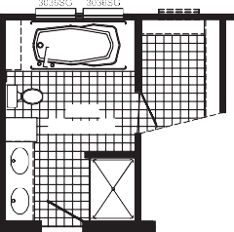
OPT
OPT 3012
36 X 72
BATH

18" 8'-2" X 12'-8"
LINEN

OPT

OPTION PATIO DOOR SLIDE
OPT. 6072 E W/TRANSOM

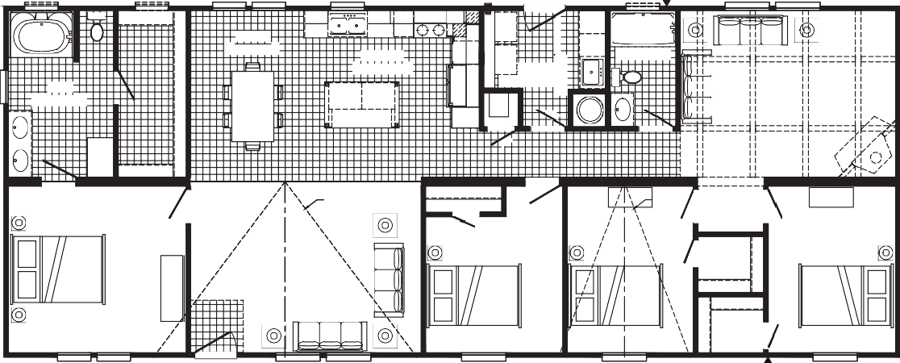
OPT FAUCET
3680
OPT DRWR
D.W
60" TUB
DINING 8'-7" X 12'-8"
BATH
KITCHEN 13'-4" X 12'-8"
60"
2ND BATH
5'-0" X 8'-11"
UTILITY 9'-4" X 8'-11"
FAMILY ROOM 16'-4" X 12'-8"
8'-0" X 12'-8"
F
18"
PANTRY
W/H
EGRESS
36" LINEN
OPT
OPT.
20' DORMER
OPT.
10' DORMER
4TH BEDROOM
10'-6" X 12'-8"
3RD BEDROOM
9'-8" X 12'-8"
2ND BEDROOM
9'-9" X 12'-8"
LIVING ROOM 17'-6" X 12'-8"
PRIMARY BEDROOM 13'-7" X 12'-8"
3680
OPT. LAUNDRY OPT. CABINETS 4' SINK

4060

4060

4060

3012
OPT. CUBBIES
3036
REFER
WASH DRY
3012
3060
3060 3036
3012
4060
4060

OPT. BATH
RAG
48 SHWR
FP
RAG
RAG

3060 3060E

4060 4060

4060E 4060E

FAUCET OPT.

4060E

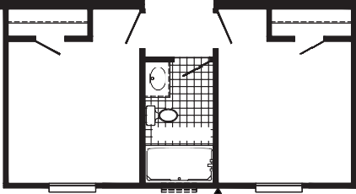
3RD BEDROOM
9'-8" X 12'-8"
2ND BEDROOM
9'-9" X 12'-8"
5'-0" X 8'-11"
3RD BATH
60"

4060E
OPT 3012
FAUCET OPT.
4060E

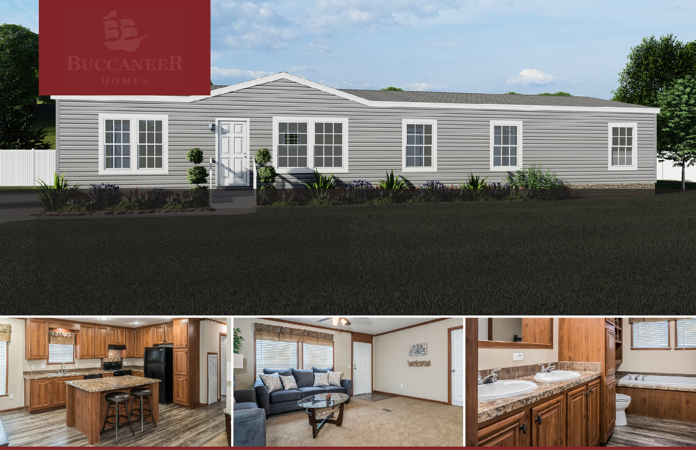
The home series and floor plans indicated will vary by retailer and state. Your local Home Center can quote you on specific prices and terms of purchase for specific homes. Buccaneer Homes invests in continuous product and process improvement. All home series, floor plans, specifications, dimension, features, materials, availability, and starting prices shown on this website are artist’s renderings or estimates, and are subject to change without notice. Dimensions are nominal and length and width measurements are from exterior wall to exterior wall.

