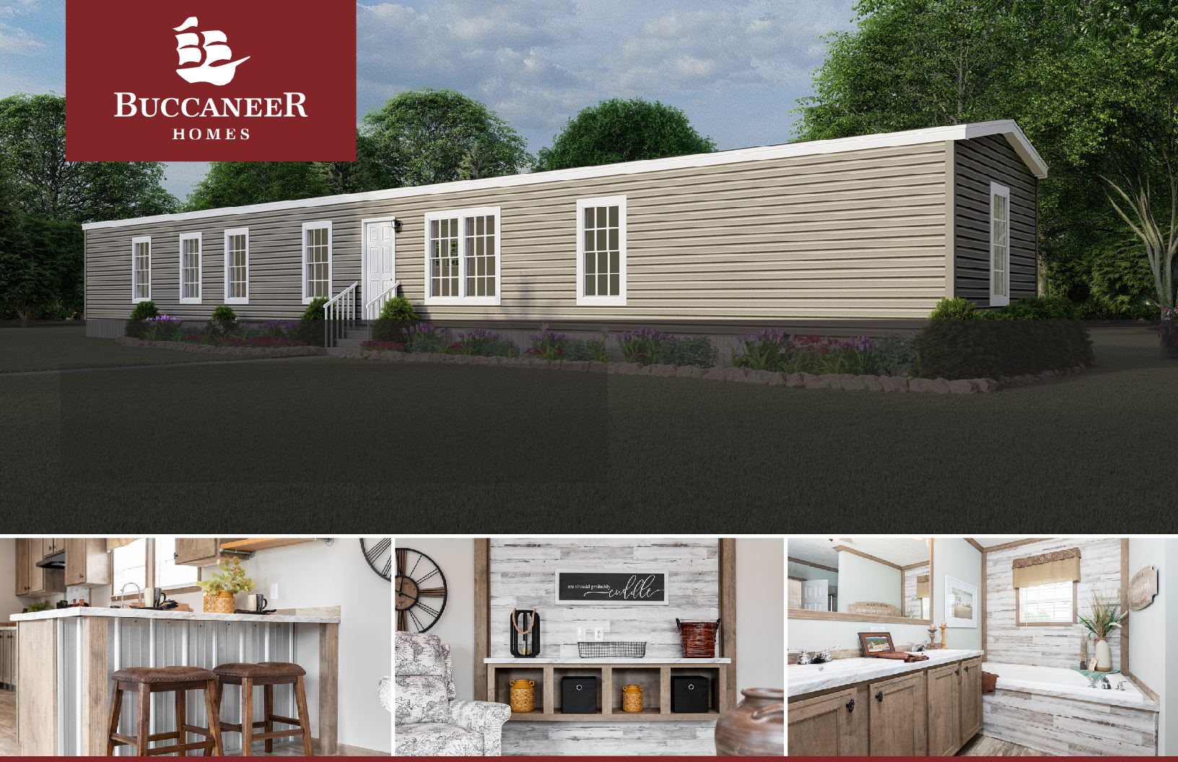
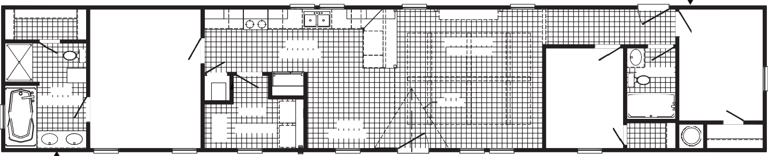
3036
3036
OPT. 3012 TR
OPT. 3012 TR
FAUCET
OPT SHELVES
3680
OPT. ENT. CTR.
DRWR
OPT. DW
KITCHEN 19'-5" X 7'-2"
LIVING ROOM 15'-1" X 14'-4"
LINEN
5'-0" X 7'-4"
REFER
OPT. BEAM
BATH
8'-4" X 10'-10"
F
2ND BEDROOM
8'-7" X 11'-6"
OPT. DORMER
OPT. TREY CEILING
2ND BATH
60"
UTILITY
PRIMARY BEDROOM 11'-4" X 14'-4"
10'-2" X 7'-6"
DINING
8'-8" X 7'-2"
3RD BEDROOM
7'-11" X 10'-4"
W/H
3680
OPT.FAUCET
3060-E
3060
3060
3060
3060
3060
3060-E
RAG
3036 SG
36 X 72
48 SHWR
FREEZER SPACE
DRY
WASH
OPT. BEAM
OPT. BEAM
OPT. BEAM
OPT. BEAM
OPT. BEAM
OPT. BEAM
3060-E
RAG

The Marion B2036ADM
1,170 Sq Ft | 3 Beds | 2 Baths | 16x82

The home series and floor plans indicated will vary by retailer and state. Your local Home Center can quote you on specific prices and terms of purchase for specific homes. Buccaneer Homes invests in continuous product and process improvement. All home series, floor plans, specifications, dimension, features, materials, availability, and starting prices shown on this website are artist’s renderings or estimates, and are subject to change without notice. Dimensions are nominal and length and width measurements are from exterior wall to exterior wall.

