The Bexar 2029ADM
1,170 Sq Ft | 3 Beds | 2 Baths | 16x78

OPT. PATIO DOOR SLIDE
48 SHWR
FREEZER SPACE
WASH
DRY

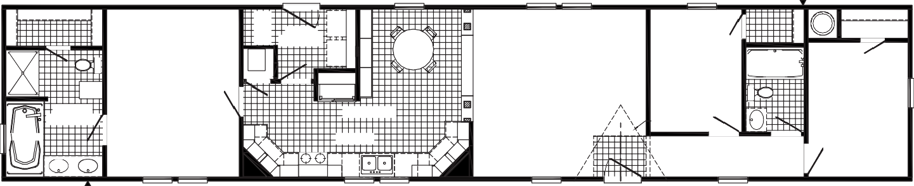
FAUCET OPT.
3060
3060
3060
3060-E
FAUCET
3680
W/H
UTILITY 9'-8" X 6'-0"
DINING
LIVING ROOM 14'-10" X 14'-4"
3RD BEDROOM
7'-10" X 10'-6"
F
2ND BATH
60"
5'-0" X 7'-2"
LINEN
REFER
PR. BATH 8'-3" X 10'-10"
19'-4" X 14'-4"
PRIMARY BEDROOM 11'-4" X 14'-4"
OPT. DORMER
KITCHEN
2ND BEDROOM
8'-7" X 11'-6"
DB
OPT. DW
3680

3060-E 3060
3036 SG
36 X 72

3036 3036

3060 3060
RAG
3060-E
OPT.

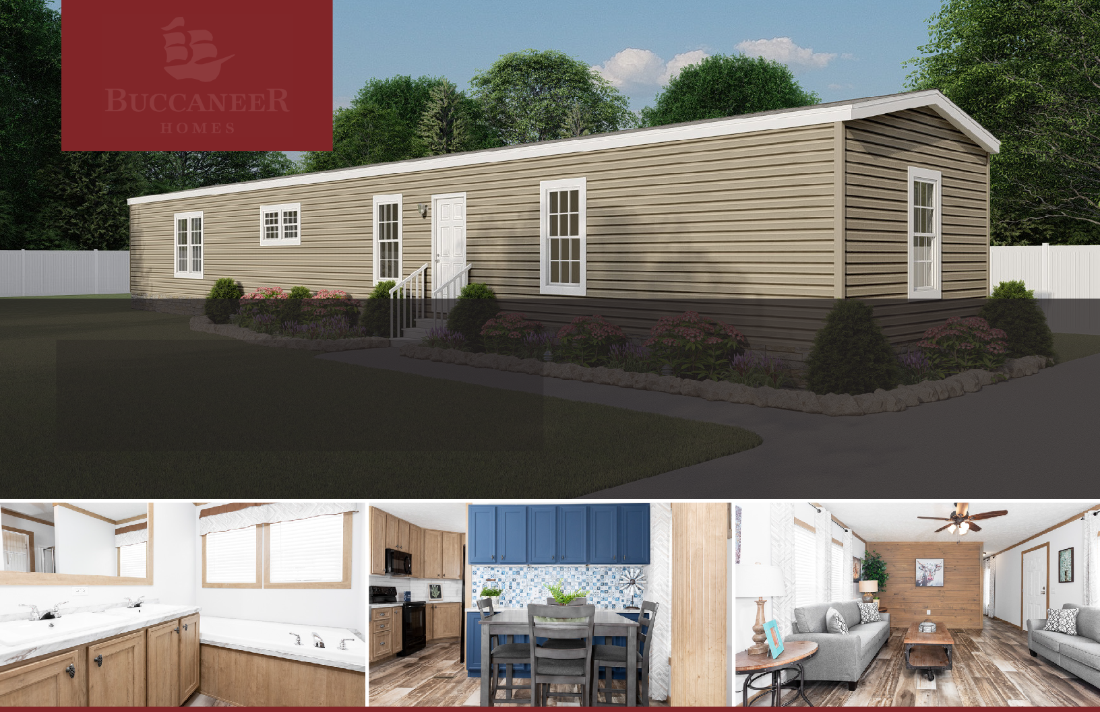

The home series and floor plans indicated will vary by retailer and state. Your local Home Center can quote you on specific prices and terms of purchase for specific homes. Buccaneer Homes invests in continuous product and process improvement. All home series, floor plans, specifications, dimension, features, materials, availability, and starting prices shown on this website are artist’s renderings or estimates, and are subject to change without notice. Dimensions are nominal and length and width measurements are from exterior wall to exterior wall.

