The Walsh 2001COM
1,140 Sq Ft | 3 Beds | 2 Baths | 16x76

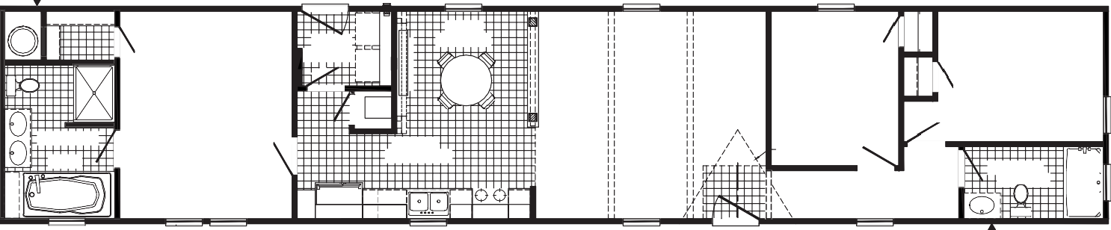
OPT 7280 PATIO DR SLIDE
FAUCET
3060
3060
3060-E
3680
W/H
DINING 9'-2" X 8'-6"
PRIMARY BEDROOM 11'-10" X 14'-4"
UTILITY 6'-6" X 5'-2"
LIVING ROOM 15'-10" X 14'-4"
3RD BEDROOM
8'-9" X 10'-8"
2ND BEDROOM
13'-9" X 9'-0"
F
7'-7" X 10'-8"
OPT. DORMER
BATH
KITCHEN 16'-0" X 5'-11"
9'-1" X 5'-0"
2ND BATH
36 X 72
REFER
OPT. DW
3680
3036 SG
3060-E 3060
3036
3060
3060
OPT.
FAUCET
RAG
OPT. CUBBIES
48 SHWR
WASH
DRY
OPT. FEATURE WALL
OPT. BEAM
OPT. BEAM
60"
3012 TR OPT.
3060-E
RAG

OPT. WINDOWS
3060 3060

3060

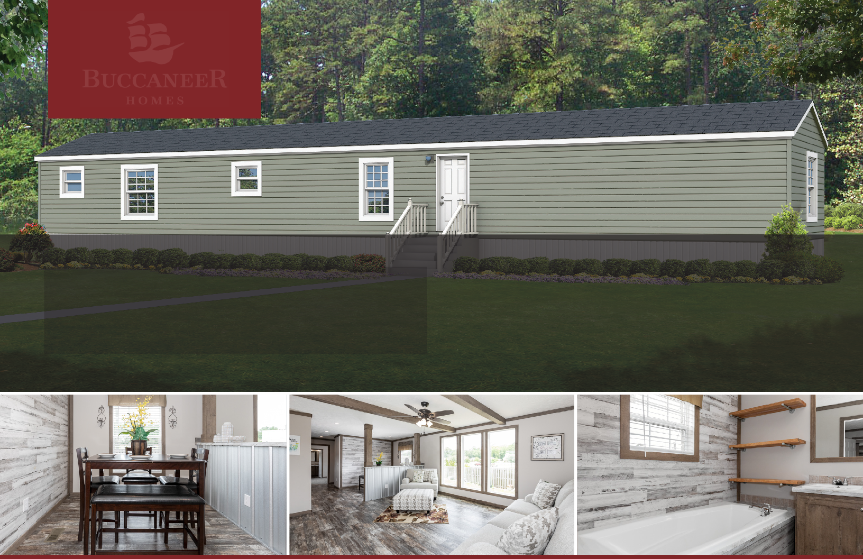
PANTRY
DRWR

The home series and floor plans indicated will vary by retailer and state. Your local Home Center can quote you on specific prices and terms of purchase for specific homes. Buccaneer Homes invests in continuous product and process improvement. All home series, floor plans, specifications, dimension, features, materials, availability, and starting prices shown on this website are artist’s renderings or estimates, and are subject to change without notice. Dimensions are nominal and length and width measurements are from exterior wall to exterior wall.

